**studied less in depth than OSPF for CCNA**

# **25. RIP and EIGRP (IGP: Dynamic Vector)**

## **Routing Information Protocol (RIP)**

### **Key Characteristics**

* **Industry Standard**: A distance-vector IGP that uses *Routing-By-Rumor* logic to learn/share routes.
* **Metric**: Uses **Hop Count** (One Router = One Hop), disregarding bandwidth.
* **Max Hop Count**: 15 (Routes beyond this are considered unreachable).

### **Versions**

1. **RIPv1**: Supports only classful addressing, does not include subnet masks.
2. **RIPv2**: Supports VLSM and CIDR, includes subnet masks in advertisements.
3. **RIPng**: Designed for IPv6.

### **Message Types**

* **Request**: Asks RIP-enabled neighbors for their routing tables.
* **Response**: Sends the local router's routing table to neighbors.

By default, RIP-enabled routers share their routing table every **30 seconds**.

### **RIPv1 Details**

* Only advertises **classful addresses**:
  + **Example**:
    - 10.1.1.0/24 → 10.0.0.0 (Class A, /8 assumed).
    - 172.16.192.0/18 → 172.16.0.0 (Class B, /16 assumed).
* Does not support **VLSM** or **CIDR**.
* Broadcasts updates to 255.255.255.255.

### **RIPv2 Details**

* Supports **VLSM** and **CIDR**.
* Multicasts updates to 224.0.0.9 (not broadcast).
  + **Broadcast vs. Multicast**:
    - Broadcast delivers to all devices.
    - Multicast delivers only to specific group members.

### **RIP Configuration**

1. **network** command: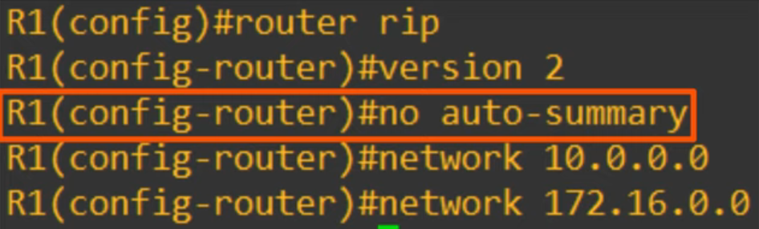  
   * Activates RIP on interfaces within the specified range.
   * Forms adjacencies with RIP neighbors.
   * Advertises the **network prefix** of the interface.
2. **Classful Nature**:  
   * Example:
     + network 10.0.0.0 assumes /8.
     + RIP activates on interfaces within 10.0.0.0/8 and advertises prefixes like 10.0.12.0/30.
3. **Passive Interface**:  
   * Stops RIP advertisements on specified interfaces without disabling prefix advertisement.

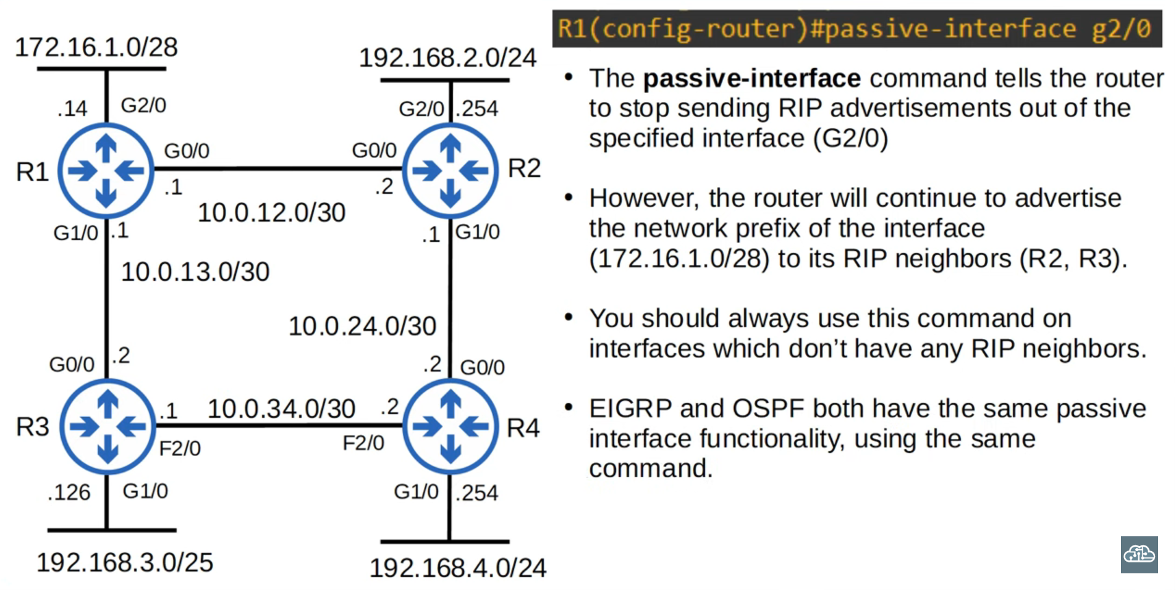

### **Advertising Default Routes in RIP**



* Use the default-information originate command to share default routes.
* RIP prefers the path with the least hops for default route selection.

### **Useful Commands for RIP**

* show ip protocols: Displays RIP configuration.
* Adjustments:
  + Maximum paths: maximum-paths <value>.
  + Administrative Distance: distance <value>.

## **Enhanced Interior Gateway Routing Protocol (EIGRP)**

### **Key Characteristics**

* **Distance Vector IGP**: Advanced/hybrid version, proprietary to Cisco but now open.
* **Advantages**:
  + Faster than RIP in network changes.
  + No hop limit (unlike RIP's 15).
  + Supports **unequal-cost load-balancing**.
* **Multicast Address**: 224.0.0.10 (memorize this).

### **EIGRP Configuration**

1. **router eigrp** :  
   * AS numbers must match for adjacency formation.
   * Disable auto-summary if enabled.
2. **Wildcard Masks**:  
   * Inverted subnet masks.
   * 0 = Bits must match.
   * 1 = Bits can vary.
3. **Network Command**:  
   * Similar to RIP but uses wildcard masks.

### **Metrics**

* Calculated using **Bandwidth** and **Delay**.
* Default K values:
  + K1 = 1, K2 = 0, K3 = 1, K4 = 0, K5 = 0.
* Simplified Metric Formula:
  + Metric = Bandwidth (slowest link) + Delay (sum of all links).

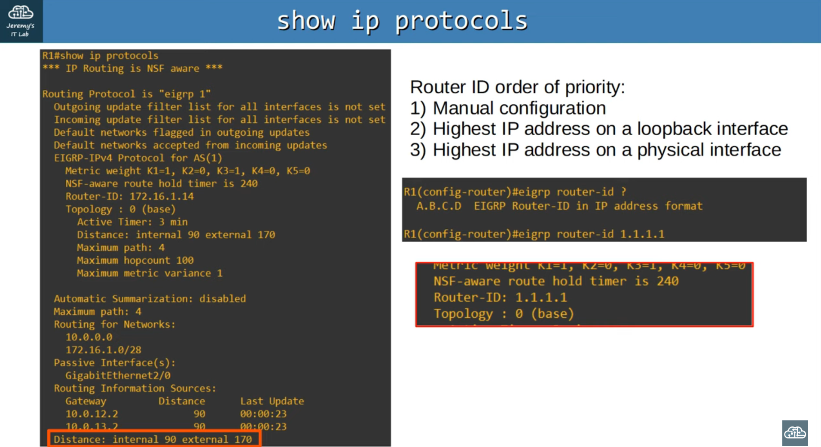

### **EIGRP Terminology**

* **Feasible Distance** (FD): Router's metric to a destination.
* **Reported Distance** (RD): Neighbor's metric to a destination.
* **Successor**: Best route (lowest metric).
* **Feasible Successor**: Backup route meeting the **feasibility condition**.

### **Feasibility Condition**

* A route is a feasible successor if its RD < FD of the successor.

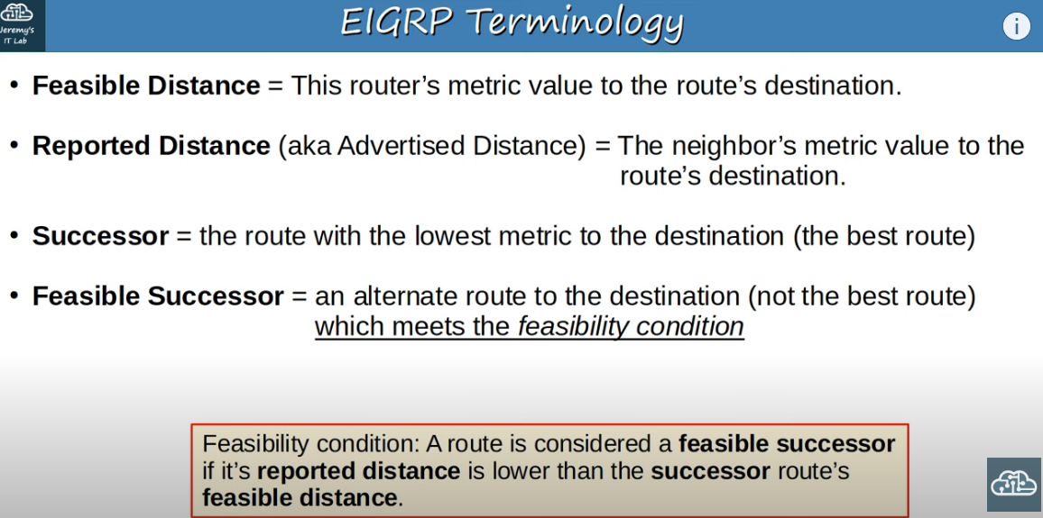

### **Unequal-Cost Load-Balancing**

* **Variance** command adjusts the threshold for load-balancing.
* Only feasible successors are considered for unequal-cost load-balancing.

### **Key Commands**

1. show ip protocols: Displays EIGRP settings.
2. Adjustments:
   * Variance: variance <value>.
   * Distance: Internal = 90, External = 170.